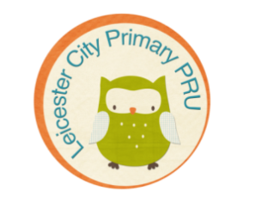**PRU Newsletter Summer 1 2017/18**

# 

# **Welcome!**

Hello everyone, it is lovely to see some sunshine at last! This term we have started working on the Artsmark award, which is a national accreditation for schools to recognise the work they do in the Arts. For us this is a really important award which will bring together our whole curriculum and allow us to have a focus on the issues of equality and diversity. Our Arts Exhibition was the first major activity towards the Artsmark and it was lovely to share that with some of you. There will be many more events on our 2 year journey toward achieving the award.

As always, the pupils have been busy in and out of school. Our Year 6’s are getting ready for their SATs and we are really proud of how well they are working. In February we had a mini inspection by the Local Authority who were really pleased to see how well the pupils are learning and the quality of lessons they are having.

I continue to be incredibly proud to be Headteacher of Leicester City Primary PRU – your children make us smile, every single day!

Nic

## **Name the Owl Competition**

## All children at the PRU had the chance to decide on the name of the owl on our school logo. The leadership team shortlisted 3 names, which then went to a staff vote to choose the final winner. Oreo was the winning name by a clear lead, and was suggested by Leyland Almond-Backhouse. Leyland won a £10 gift card. Congratulations Leyland!



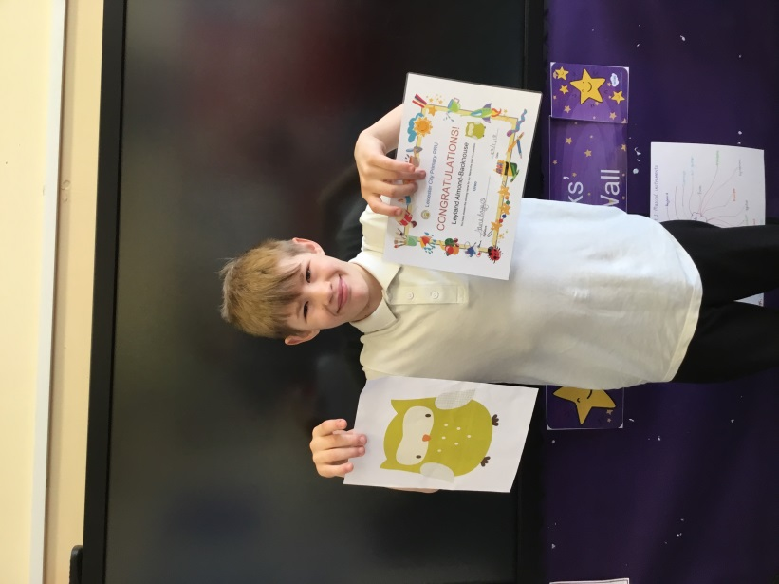

## **E-Safety**

## The children took part in e-safety week and learnt about how to keep themselves safe online by thinking about their personal profiles, what information they share about themselves with strangers or online friends, and they thought about rules they could use to keep themselves safe.

## We had Matt Turner and Katie Hudson from Leicestershire Police join us this week to run an E-safety workshop for parents. They covered issues such as online grooming, games that our children are playing online, and how easily our personal information can be shared through social media sites.

Along with the E-safety sections for both children and parents on our website, there are the following websites which are great resources for both parents and children:

* CEOP – Child Exploitation & Online Protection - [www.ceop.police.uk](http://www.ceop.police.uk/)
* Leicestershire Police - [www.leics.police.uk/kidsandteens](http://www.leics.police.uk/kidsandteens)
* Kayleigh’s Love story - <https://www.youtube.com/watch?v=WsbYHI-rZOE>
* UK Safer Internet Centre - [www.saferinternet.org.uk](http://www.saferinternet.org.uk/)
* Internet Watch Foundation - [www.iwf.org.uk](http://www.iwf.org.uk/)
* Get Safe Online - [www.getsafeonline.org](http://www.getsafeonline.org/)
* Know the Net - [www.knowthenet.org.uk](http://www.knowthenet.org.uk/)
* Thinkuknow – [www.Thinkuknow.co.uk](http://www.thinkuknow.co.uk/)

Thinkuknow which is the educational and prevention side of CEOP have created a selection of resources for parents/ carers, children and young people.

* Parent Info - [https://parentinfo.org](https://parentinfo.org/)
* Child line – [www.childline.org.uk](http://www.childline.org.uk/)
* Childnet - [www.childnet.com](http://www.childnet.com/)
* NSPCC – [www.nspcc.org.uk](http://www.nspcc.org.uk/)

The NSPCC along with O2 have created the Share Aware booklet with this newsletter. There is also an app called NetAware to download onto your mobile phone or tablet.

The NSPCC have also created a selection of resources for younger children to help them understand what to do if someone asks for an image and the dangers of sharing. These videos have been created to help parents have that conversation with their children and offering a visual aid to engage children and help their understanding.

* **Lucy and the boy** <https://www.youtube.com/watch?v=kwcL-VP3FYc>
* **I saw your willy** <https://www.youtube.com/watch?v=sch_WMjd6go>
* **Pantosaurus** <https://www.youtube.com/watch?v=yyalcd955lg>

|  |  |
| --- | --- |
| Logo | Description |
|  | **Ask.fm** is a Q&A-based site (and app) that lets users ask questions to followers and others, people then answer them one at a time, any time they want. The answers can be given as text or a video. Users can view other peoples profiles with an option to submit a direct question to them. **Age rating 12+** |
|  | **BlackBerry’s BBM** is an instant messaging app. You have your own unique 4 digit PIN and other people can only add you as a contact using this. As well as instant messaging, you can have group chats, voice calls and video calls, you can also share voice notes and pictures. you can see when your messages have been delivered and read. **Age rating 4+** |
|  | **Clash of Clans** is a combat game where players build their own armies (clans) and battle against other armies from around the world. You can join forces with other armies or simply battle against others on your own. Free to download and play but some extra items come at a cost. **Age rating 13+** |
|  | **Club Penguin Island**, create you penguin explore, hang out and chat with friends whilst creating a new style. You can discover a land of adventure, games, fashion and music. **Age rating 9+** |
|  | **Facebook** is one of the most popular social network on the web today. Facebook’s user base consists of more than 500 million individuals. The site offers up everything social networking users want, including status updates, wall posts and private messages, uploading images & videos and creating a your story. **Age rating 13 +** |
|  | **Facebook Messenger** is an app which allows users to communicate with their friends from either their Facebook account, or their phonebook. Users can instant message, create group chats, share photos and videos, record voice messages, have live video chats, or simply talk to their friends and family. **Age rating 13+** |
|  | **FMyLife** is an online community where you can post a short caption about an unfortunate incident that has happened during your day. The caption usually starts with “today…” and ends with “FML”. You can also comment on other people’s stories. **Age rating 17+** |
|  | **Google +** enables you to explores your interests and join and connect with communities of people around any topic. Create collections of things you love. **Age rating 17+** |
|  | **Instagram** lets users snap, edit, and share photos and 15-second videos, either publicly or with a private network of followers. It unites the most popular features of social media sites: sharing, seeing, and commenting on photos. It also lets you apply fun filters and effects to your photos, making them look high-quality and artistic. **Age rating 12+** |
|  | **Kik Messenger** is an app that lets you text for free in groups or private conversations. It's fast and has no message limits, character limits, or fees if you only use the basic features. Because it's an app, the texts won't show up on your kid's phone's messaging service. **Age rating 17+** |
|  | **Live.me** as a broadcasting app in which youn can chat, share, follow. Is a tool for broadcasting live-streaming videos and watching others' videos. You can send and receive virual gifts. **Age rating 17+** |
|  | **MeetMe** helps you to find new friends nearby who share the same interests and want to chat. **Age rating 17+** |
|  | **Minecraft** is a game that lets you build and create a virtual world using building blocks. Other activities include using the multiplayer function to explore the worlds created by other users and to combat, chat and play with them. **Age rating 9+** |
|  | **Musical.ly** one of the biggest creative platforms, you can make videos to share with friends and or to the world, the app has various face and voice filters. **Age rating 12+** |
|  | **ooVoo** is a video chat app. It lets you make video calls, voice calls and send texts to friends and family. You can also start a group video chat with up to 12 people. The default privacy settings are set to 'public', so you can talk to people you don't know, but they can be changed so that you can just talk to your friends. **Age rating 4+** |
|  | **Periscope** is a live video broadcasting/ streaming app Periscope is linked to mapping therefore if this is nor turned off people can see your location. **Age rating 17+** |
|  | **Pinterest** is a photo sharing website where you can upload and save individual pins to one of their own boards using the "Pin It" button, with pinboards typically organized by a central topic or theme. Users can personalize their experience by pinning items, creating boards, and interacting with other members. The end result is that the "pin feed" of each user displays unique, personalized results. **Age rating 12+** |
|  | **ROBLOX** is a user-generated gaming platform where you can create your own games or play games that other users have made. There is also the option to chat to other players. **Age rating 12+** |
|  | **Snapchat** is a messaging app that lets users put a time limit on the pictures and videos they send before they disappear.  Snapchat is an app developed in the US and is therefore governed by US law. Snapchat is now linked to mapping therefore if this is not turned off it shows your exact location. **Age rating 12+** |
|  | **Tumblr** is a app to discover and post about the things you love, join communities or people who have the same interest. You can post photos, videos, live videos, songs, text pretty much anything. **Age rating 17+** |
|  | **Twitter** is a social network that lets people share status updates in a short, concise format. The application works by giving users access to an account. The user can build up a contact list and followers, who will receive updates each time the user posts a new status. **Age rating 17+** |
|  | **WhatsApp** lets users send text messages, audio messages, videos, and photos to one or many people with no message limits or fees. It also allows you to make calls and video calls. **Age rating 4+** |
|  | **Yellow** is a social app to meet new friends. You can have one on one or group chats, create live video rooms with up to 4 people, group video chat and create your profile. **Age rating 12+** |
|  | **YouNow** allows you to chat with live broadcasters and connect with your audience by going live. Join the fun broadcasting, creating selfies, sending gifts and interacting with the you now community. **Age rating 12+** |
|  | **YouTube** is a place to watch, create and share videos. You can create your own YouTube account, make a music playlist, and even create your own channel, which means you will have a public profile, and it allows you to comment on videos and create video playlists. For younger children there is a separate YouTube for Kids site. **Age rating 17+** |

**Mental Health Week**

Last term we all took part in Mental Health Week and were all encouraged to celebrate our uniqueness. It was all about #BeingOurselves and that when we have a positive view of ourselves, it can help us to cope with life’s challenges. Recognising the different qualities of others can allow us to connect with those around us, making positive relationships, which is vital for our own and others’ wellbeing.

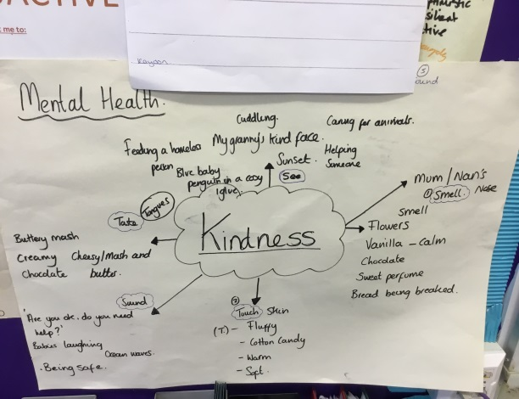 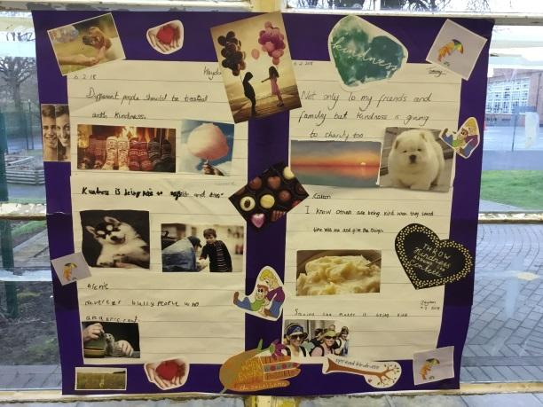

## **Year 6 SATs**

## Our Year 6 children are very busy and working hard to prepare themselves for their SATs. This year they take place from Monday 14th – Thursday 17th May. If your child is part time at the PRU, they will do their SATs at the mainstream school, and transport changes have been made to bring them to the PRU afterwards on the days they are usually here.

**Monday 14th May -** Spelling, Punctuation and Grammar

Spelling

**Tuesday 15th May -** Reading

**Wednesday 16th May -** Arithmetic

**Thursday 17th May -** Reasoning

## **Transition**

This is the time of year where we start to find out which schools many of our children will be moving on to. If a school does get in touch with you, please inform your child’s teacher. We are happy to support your child moving on in any way and support visits to new schools. Many schools also send their own staff to visit children here at the PRU to start building relationships. If you have any concerns or questions, please just ask.

## **Artsmark and Art Exhibition**

## The school has started a 2 year journey working towards getting the Artsmark which focuses on how we use and develop our arts and culture provision within school. We are linking it very closely to our work on Equality and Diversity, by using the arts to challenge stereotypes and misconceptions. The arts allows our children to develop resilience, take risks and experience success in non-academic areas. The staff have been working hard to improve the range of experiences we provide our children, including their trips off-site to places like the University of Leicester and the Outdoor Pursuits centre, along with having a musician in school.

Our first major school event towards the Artsmark was a school art exhibition which all children contributed to, and many of our parents and families were able to attend.

****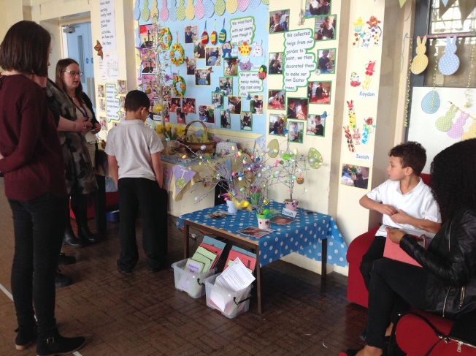

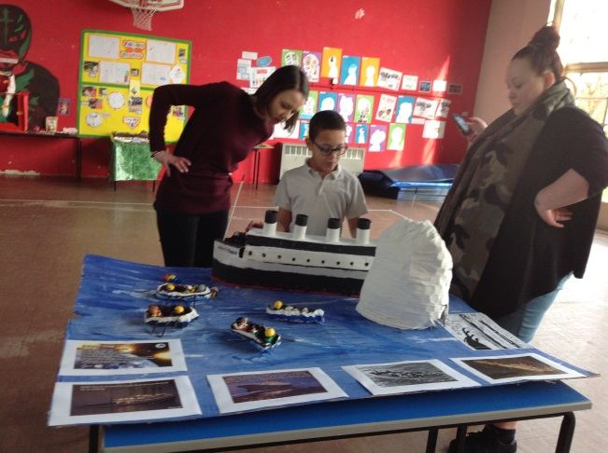

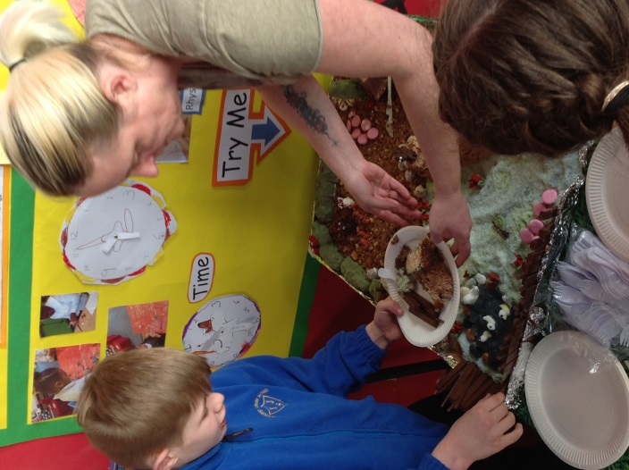

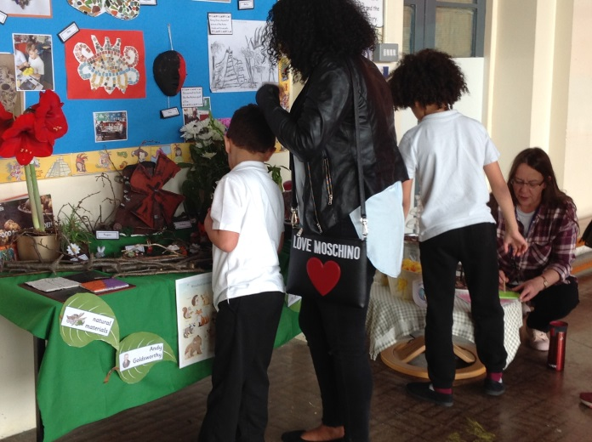

## **Cadbury’s World trip**

## The children had a great time at our end of term trip to Cadbury’s World. This trip linked to our learning on plants, including how cocoa beans are grown and the process to turn the beans into chocolate. It also linked to our work on the Aztecs. Here are some photos from our day!

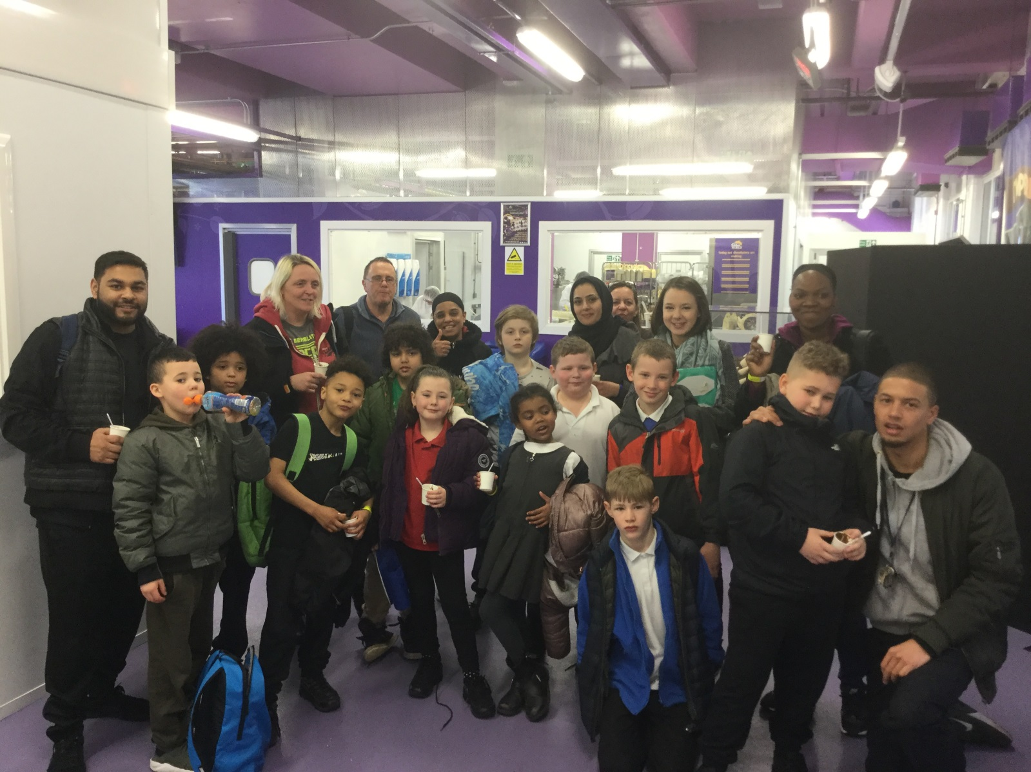

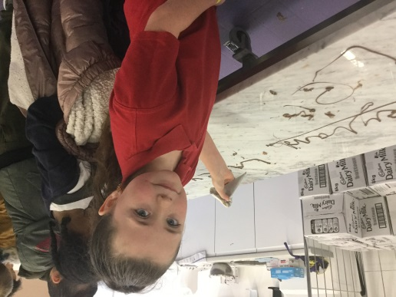 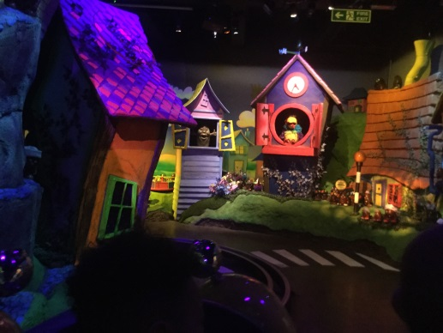 

**Regular Information**

### Uniform

The Staff and Management Committee do expect children to wear full school uniform which is as follows:

* Black/grey trousers or skirt
* White polo t-shirt or white shirt
* Plain sweatshirt
* Black plimsolls

Part time children are able to wear their mainstream school uniform.

Please be reminded that hooded tops and inappropriate slogans are not allowed. Your child will be asked to change should they be wearing inappropriate clothing. Plimsolls are essential and children must wear these at all times.

### 

### Swimming

All full time children go swimming each week at Aylestone Leisure Centre for lessons with a qualified swimming instructor. **Hawks** will go on a **Tuesday** and **Eagles and Owls** will go on a **Wednesday**. Please make sure your child brings swimming trunks or costume and a towel.

### 

### Sports

Most children go to S&S Fitness each week for a sports and exercise session and they should come prepared with thin layered clothing such as jogging bottoms, t-shirts, jumpers or light jackets. **Hawks and Falcons** will go on a **Monday** and **Eagles and Owls** will go on a **Thursday**.

**You will be informed if your child is doing any extra swimming or sports sessions.**

### Absences and Illnesses

At the PRU we actively encourage good attendance. Poor attendance is directly linked to poor attainment at school. If your child is unable to attend the PRU for any reason please contact the office on **0116 208 1470** on the first day of absence. Any cases of sickness or diarrhoea require a 48 hour absence from school.

### 

### Peanut, Allergy, Food ...Lunches

Children can choose either packed lunches or a school dinner. If you have to pay for your child’s dinner it is **£1.75** per day. Fizzy drinks, sweets, chocolate bars etc are not allowed in packed lunches. Please also note that we are a **nut free zone**.

## 

## **Diary Dates**

### 

|  |  |
| --- | --- |
| May Monday 7th  Friday 25th | School closed - May Bank Holiday  School closes for half term |
| June Monday 4th | School reopens |
| July Friday 13th | End of Term |
| August Tuesday 28th  Wednesday 29th  Thursday 30th | INSET day for staff  INSET day for staff  School opens – Autumn term |

## 

## **2018/19 academic year term dates**

This is the time of year when we start getting asked about term dates for next year, so please find below the Leicester City Council holiday dates for 2018/19.

**Please be aware that in 2018/19 Leicester City Council and Leicestershire Council have different dates at October half term as this may impact on your family.**

|  |  |
| --- | --- |
| Start of Autumn term  Half term break  End of term | Thursday 30th August 2018  22nd - 26th October 2018  Friday 21st December 2018 |
| Start of Spring term  Half term break  End of term | Tuesday 8th January 2019  18th – 22nd February 2019  Friday 12th April 2019 |
| Start of Summer term  May Day Bank Holiday  Half term break  End of term | Monday 29th April 2019  Monday 6th May 2019  27th – 31st May 2019  Friday 12th July 2019 |